Data Modelling (design process – converts requirement to data model)

1. INFORMATION is contained (entities)
2. RELATIONSHIP between data items
3. CONSTRAINTS on data

Logical Model – abstract, for conceptual design (ER, ODL)

Physical Model – record-based, for implementation (relational/UML)

[EXERCISE 1](http://www.cse.unsw.edu.au/~cs3311/19s1/lectures/01/exercises/GmailDataModel.txt)

Quality of design: correctness/ completeness/ consistency

ER model (entity-relationship) – collection of inter-related entities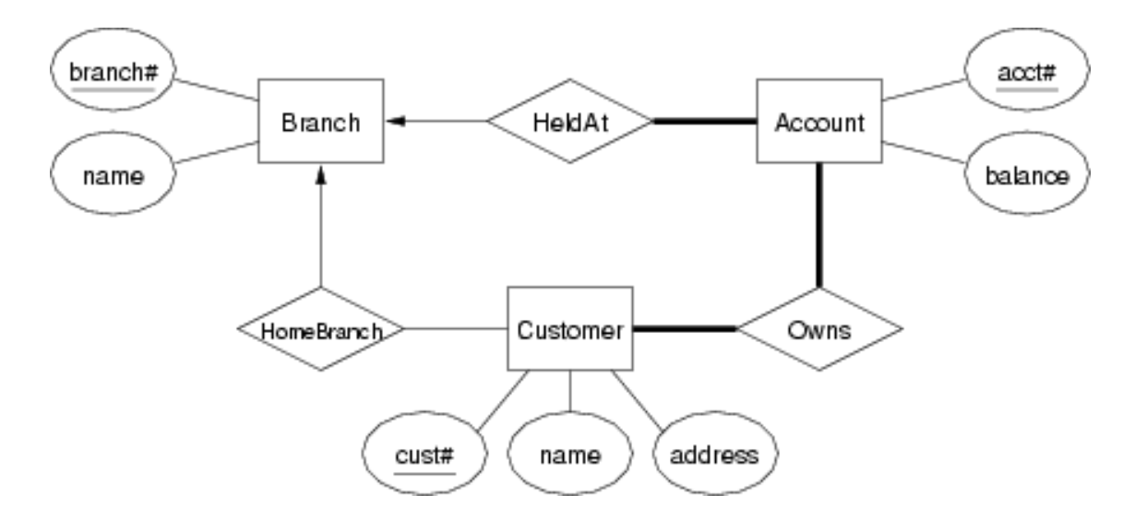

1. Attribute – data item describing a property of interest
2. Entity – collection of attributes describing object of interest
3. Relationship – association between entities(object)

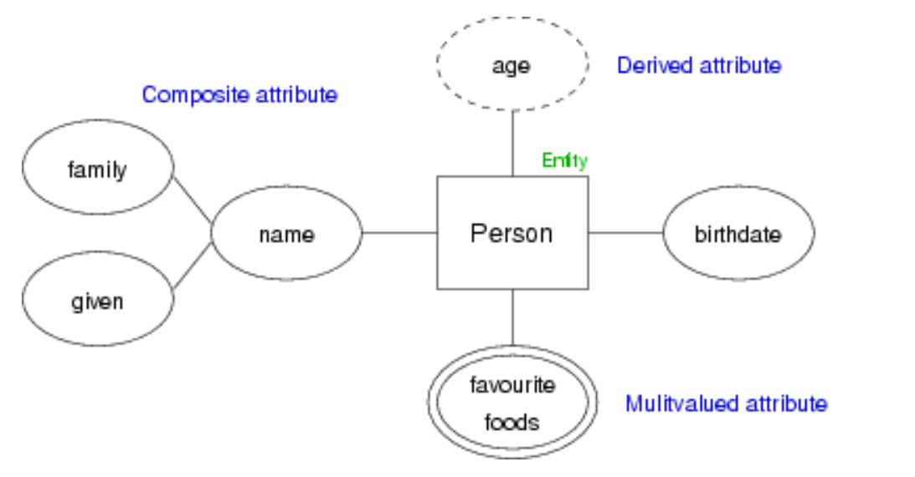

1. Composite attribute – attribute consisting more than one value for a given entity (eg. Phone no. can be more than one for a given student)
2. Derived attribute – if an attributes value can be determined from the value of other attributes (eg. Age is depends on the birthday of given student)
3. Multivalued attribute – multiple value (eg. Fav colors/foods..)

ENTITY SETS

* a set of entities with the same set of attributes
* abstraction description of a class of entities
* Key (superkey) – any set of attributes

1. Candidate key = min superkey

Value of candidate key is unique and non-null

Can be more than one

1. Primary key = candidate key chosen by DB designer

RELATIONSHIP

* Collection of relationships of the same type

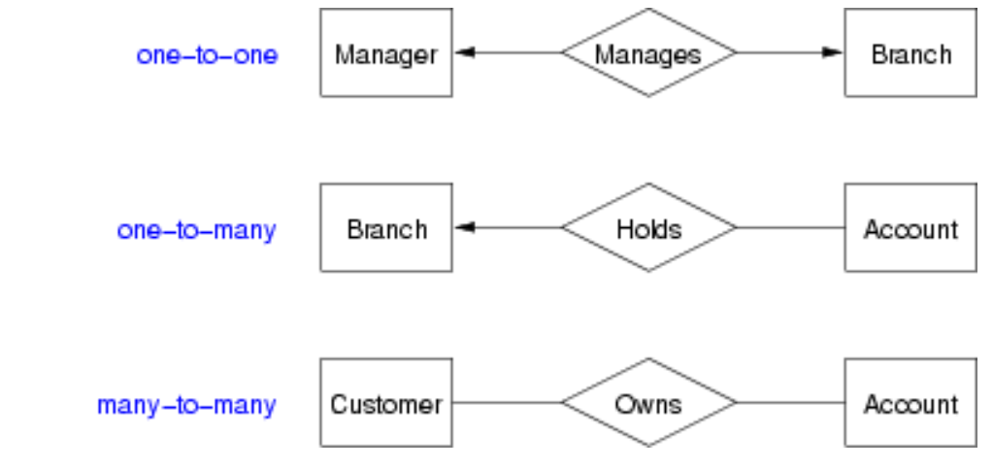 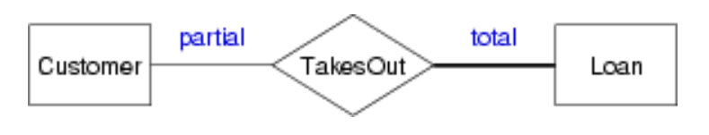

EXERCISE2:

1. 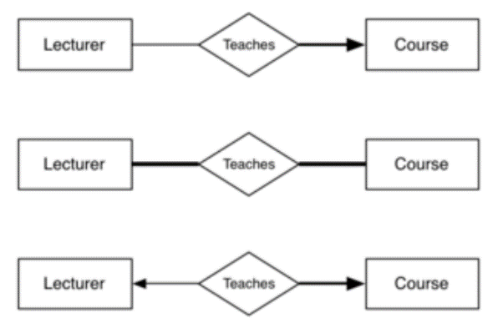one course is taught by multiple lecturers (each course must be taught by at least one lecturer but lecturer doesn’t have to teach any course)
2. many course is taught by many lecturer (each course must be taught by one lecture and each lecture must teach one course)
3. one course can only be taught by one course (each course must be taught by one lecturer but lecturer doesn’t have to teach any course)

WEAK ENTITY SETS

* exist only because of association with strong entities
* have no key of their own have discriminator

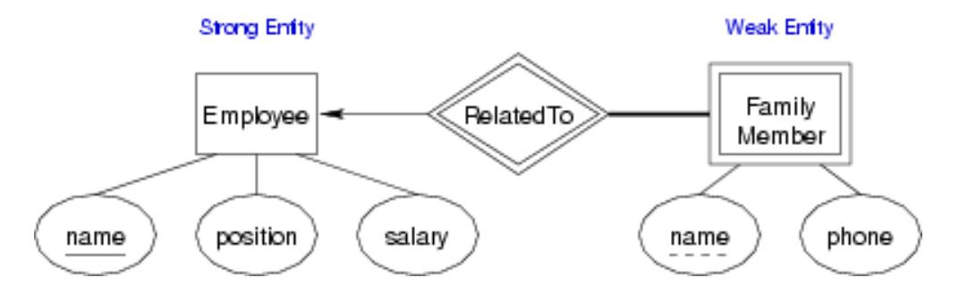

SUBCLASSES & INHERITANCE

